W-20



**11 PHYSICS ATAR**

**EVALUATION 1: AIRBAGS**

NAME: MARK:

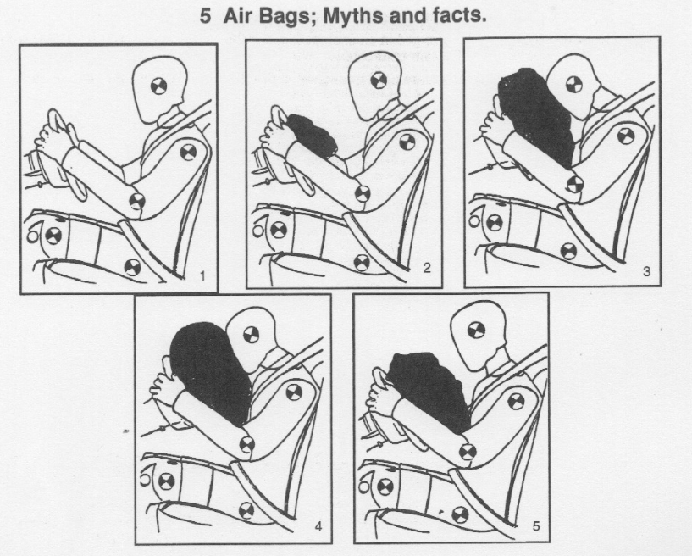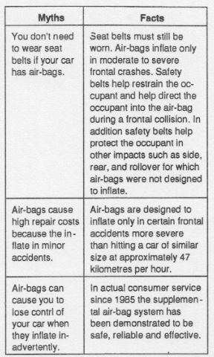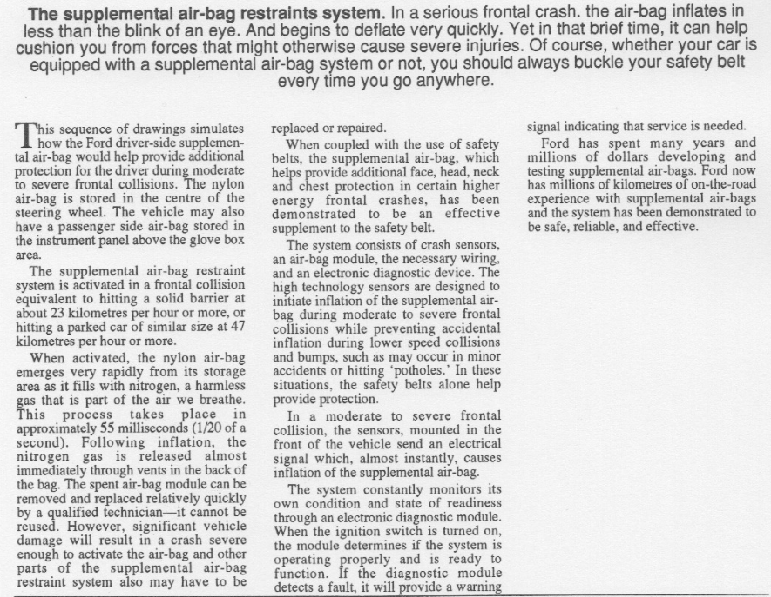

The first inflatable device for crash landings was created for an aeroplane during the Second World War. Airbags began to appear in cars in the 1980s.

1. Airbags work by increasing the time it takes to absorb the shock of an impact. Use Physics principles to explain why this is beneficial for the occupant of a car in a collision.

(4 marks)

2. In what ways does the air bag assists in minimising injury to the driver? (3 marks)

3. Why is the airbag stored in the centre of the steering wheel? (2 marks)

4. With airbags now standard in motor vehicles, do you still need to wear a seat belt? In your answer, disregard the road rules in place. Explain using Physics principles whether it is necessary.

(3 marks)

5. Air bags require sensors to deploy them. Where are these sensors located, and what do they measure? (2 marks)

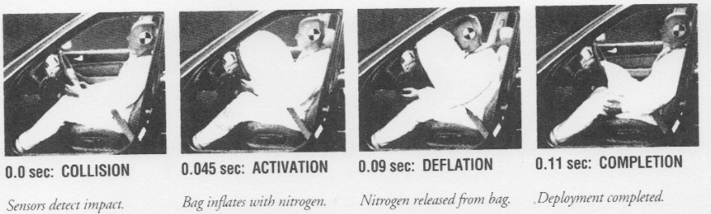

6. In these photographs provided by the Honda Motor Company, it appears that the air bag is deflated just about the same time that the driver’s head comes in contact with the bag. Why is this an important safety design? (3 marks)